COAL LAB # 7

Exercise#1

Code:
mov al,5d
add al,10d
add al,15d
result db 0
mov [result],al
ret

Output:
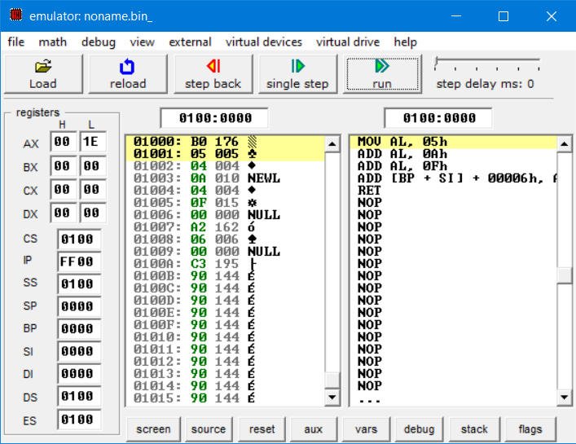

Exercise 2:

Code:
mov si,0
number db 5,10,15
mov Al,[number+si]
add al,[number+si+1]
add al,[number+si+2]
result db 0
mov [result],al
ret

Output:
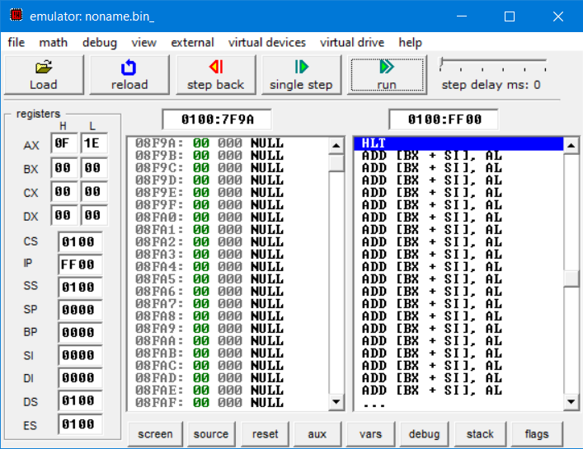

Exercise 3:

Code:
mov si,0
mov Al,[number+si]
add al,[number+si+1]
add al,[number+si+2]
number db 3,6,9
result db 0
mov [result],al
ret

Output:
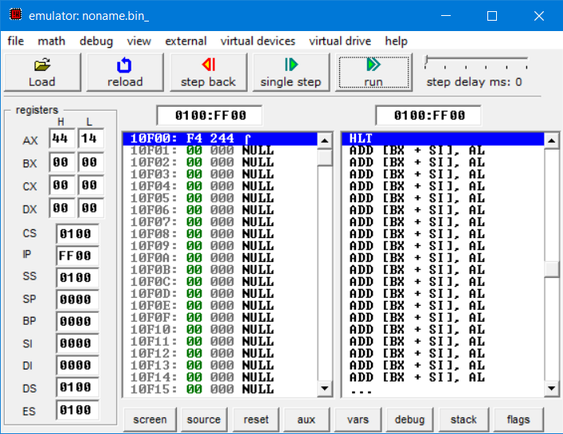

Exercise 4:

Code:
num1 db 6h
num2 db 7h
mov al, [num1]
add al,[num2]
ret

OUTPUT:
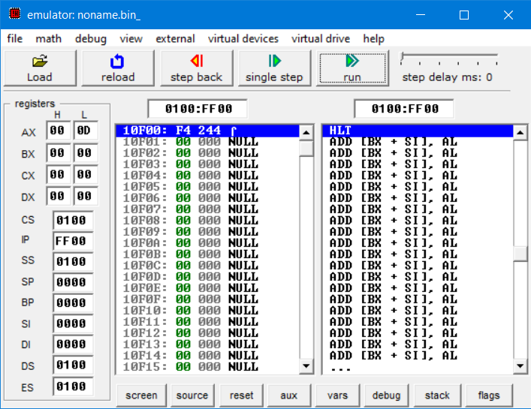

Exercise 5:

Code:
num1 db 6h
add [num1],7
mov al,[num1]
ret

OUTPUT:
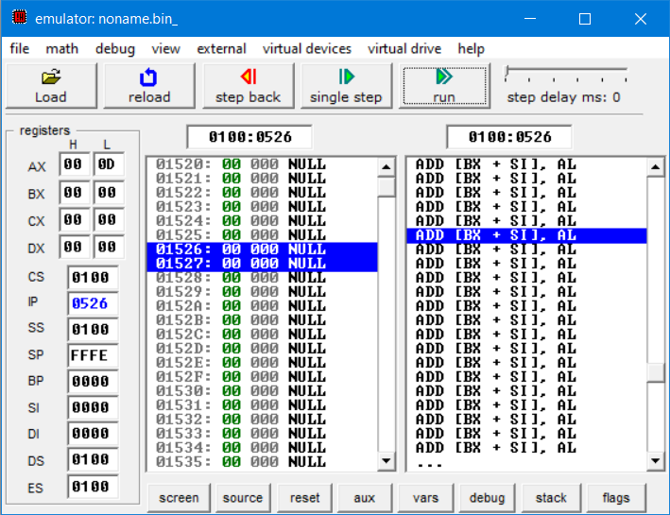

Exercise 6:

Code:
result dd 0
mov ax,12
mov bx,10
add ax,bx
mov [result],ax
ret

OUTPUT:
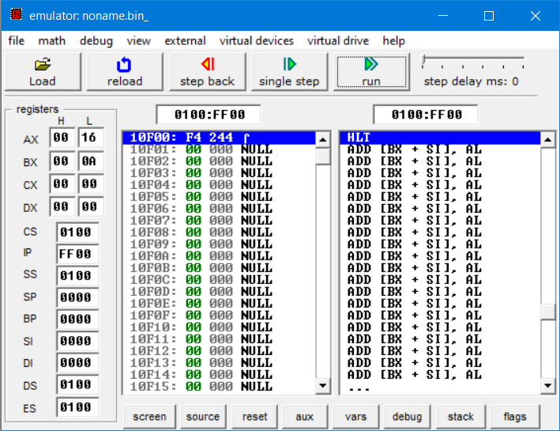

Exercise 7:

Code:
result dd 0
mov ax,12
add ax,10
mov [result],ax
ret

OUTPUT:
